KONA Macro

The KONA Macro IoT Gateway is an ideal solution for operators and enterprises that require a very scalable low cost LoRaWAN gateway that minimizes network TCO while improving coverage and capacity. In order to facilitate rapid deployment, the gateway is designed to be extremely compact and light weight. With both the cellular modem and GPS antennas embedded internally the KONA Macro is targeted at network sites that dictate a small form factor and low power consumption. Rated IP67 it is designed for the most demanding outdoor installations. The KONA Macro can be installed in various locations reducing site and deployment costs while addressing different vertical IoT applications.

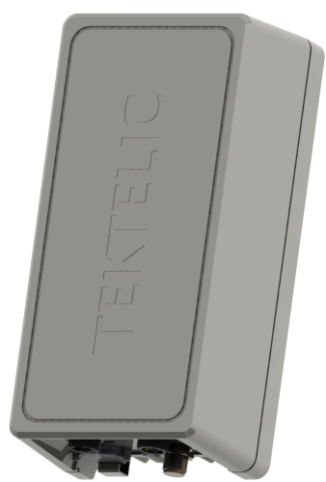

# Key Features

 Frequency Division Duplex (FDD) 16 Rx & 2 Tx Channels  Time Division Duplex (TDD) 16 Rx / 2 Tx Channels

 Global Frequency Bands: NA915, EU868, AS923, JP920, CH779, …  Extremely Compact, Simple, Reliable and Fully Integrated System

 Copper Ethernet & Global 3G/4G Backhaul Options

 Integrated Highly Selective Duplexers or Bandpass Filters  GPS Precise Network Synchronization with Hold-Over

 Optional Comprehensive & Customizable TDoA Geolocation Solution  Up to 30dBm Tx Power per Antenna

 Superior Receiver & Transmitter RF Performance

 Tier 1 Carrier Grade Design, IP-67 Enclosure, -40°C to +60°C  Multiple Deployment & Mounting Options (Tower, Pole, Wall)  Comprehensive KonaFT OA&M Tool

 Low Total Cost of Ownership Solution (Deployment and Maintenance)

# Provisioning on ChirpStack Server

This application note outlines the procedure to provision a Kona Gateway on The Things Network (TTN) Network Server.

## Required Equipment

Computer running XP/7/10

Kona Micro/Macro/Mega Gateway

KonaFT software self-extracting installer Cat 5/5e/6 Network cable

## Gateway Setup

* + 1. Connect the Ethernet ports of the gateway and computer as illustrated below.
    2. Copy the KonaFT self-extracting installer software onto the computer then double-click on the installer icon to start the installation process.
    3. Apply power to the Kona Gateway (refer to product specific user's guide). Boot up time of the Gateway is approximately 2 minutes. During boot up, the LED status is Flashing Green.
    4. The Kona Gateway supports DHCP on the Ethernet port. The Gateway MAC address is printed on the Gateway label. Using KonaFT and the MAC address determine the IP address of the Gateway.

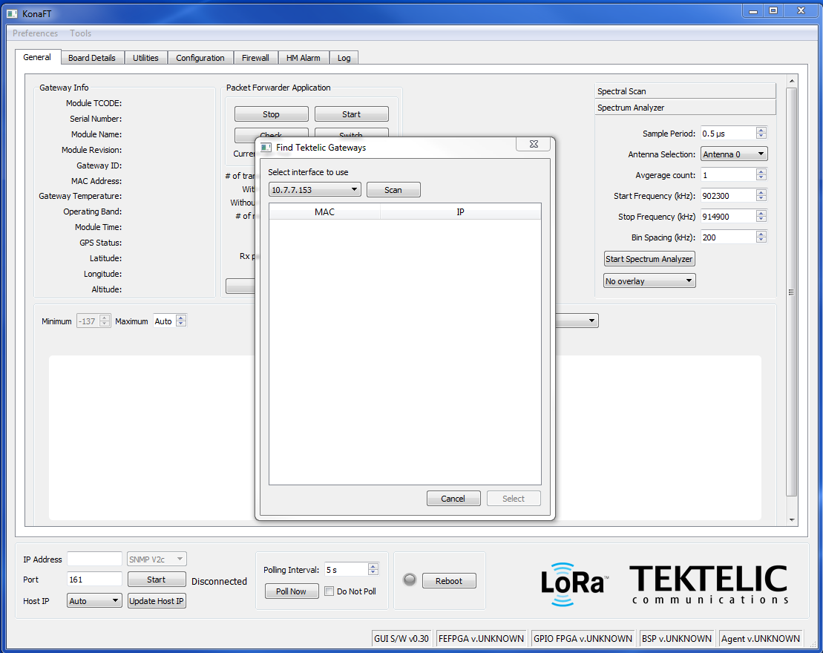 In KonaFT select **Tools** , then select **Find My Gateway** , then press **Scan**. When scanning is complete click then entry that corresponds to the Gateway's MAC address and press **Select**.

* + 1. The Gateway's IP address should appear in the bottom left corner of the KonaFT GUI. Ensure the port number is set to 161 (default), then select the Start button.
    2. Take note of the Gateway ID. This information is required for registering the gateway on the Network Server. Une image contenant texte, capture d’écran, logiciel, affichage

       Le contenu généré par l’IA peut être incorrect.

## Registering the Gateway on ChirpStack

* + 1. Login to a ChirpStack admin account.
    2. In the right-side menu, go to Gateways.
    3. Click Add Gateway.
    4. Provide the following details:
* Name: A descriptive name for your gateway.
* Gateway ID: Enter the unique Gateway ID (usually printed on the device).
  + 1. Click Submit.
    2. Une image contenant texte, logiciel, nombre, capture d’écran

       Le contenu généré par l’IA peut être incorrect.The gateway should now be listed in the interface.
  1. **Registering the Gateway on ChirpStack**

1.From the softaware KonaFT select the Configuration tab

1. Press the Refresh files button and the select config.json from the drop-down menu
2. Press the **Read** button.
3. Edit the **config.json** file to update the server_address (router address) to point the gateway to the correct router.
4. Press **Write** to save the changes to the config.json file.
5. Reboot the Gateway.
6. The Gateway should now connect to ChirpStack Network.

